**Output -:**

1. **Login Window**

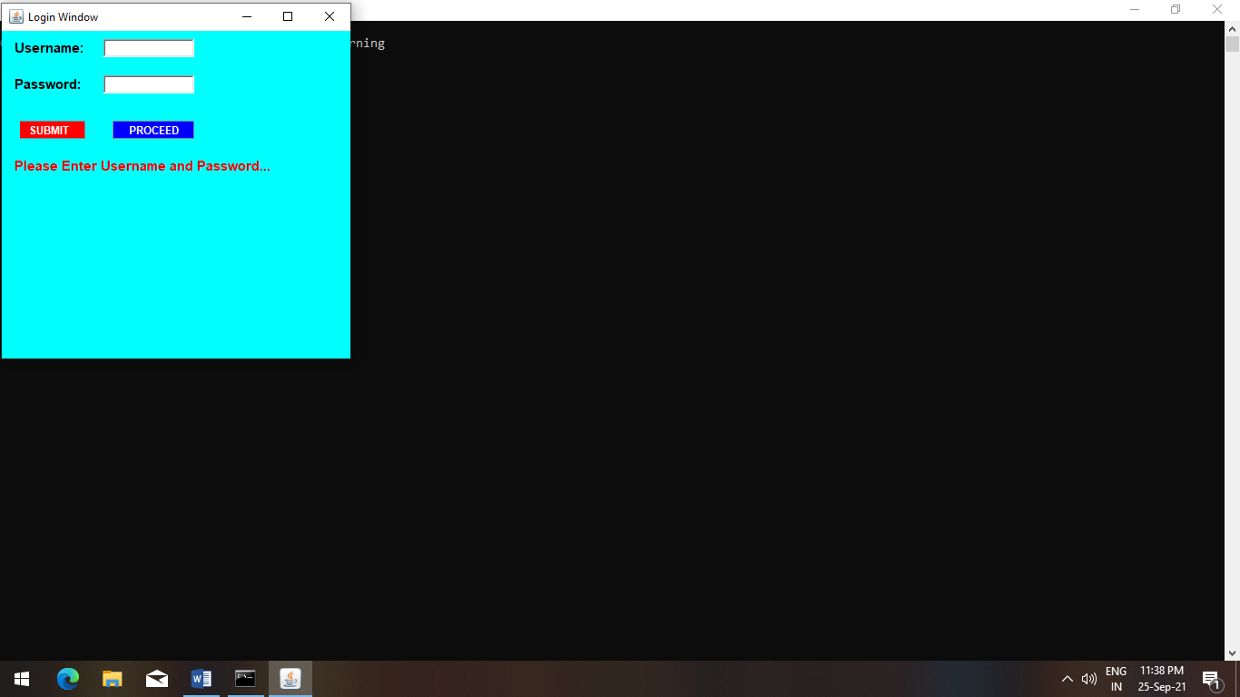

**It has Four Conditions -:**

1. **No Username and No Password**

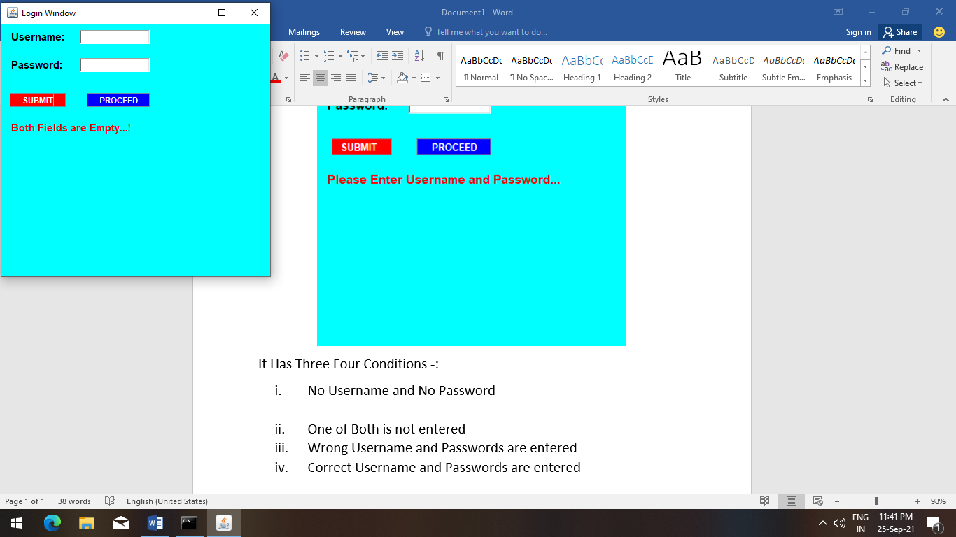

1. **One of Both is not entered**

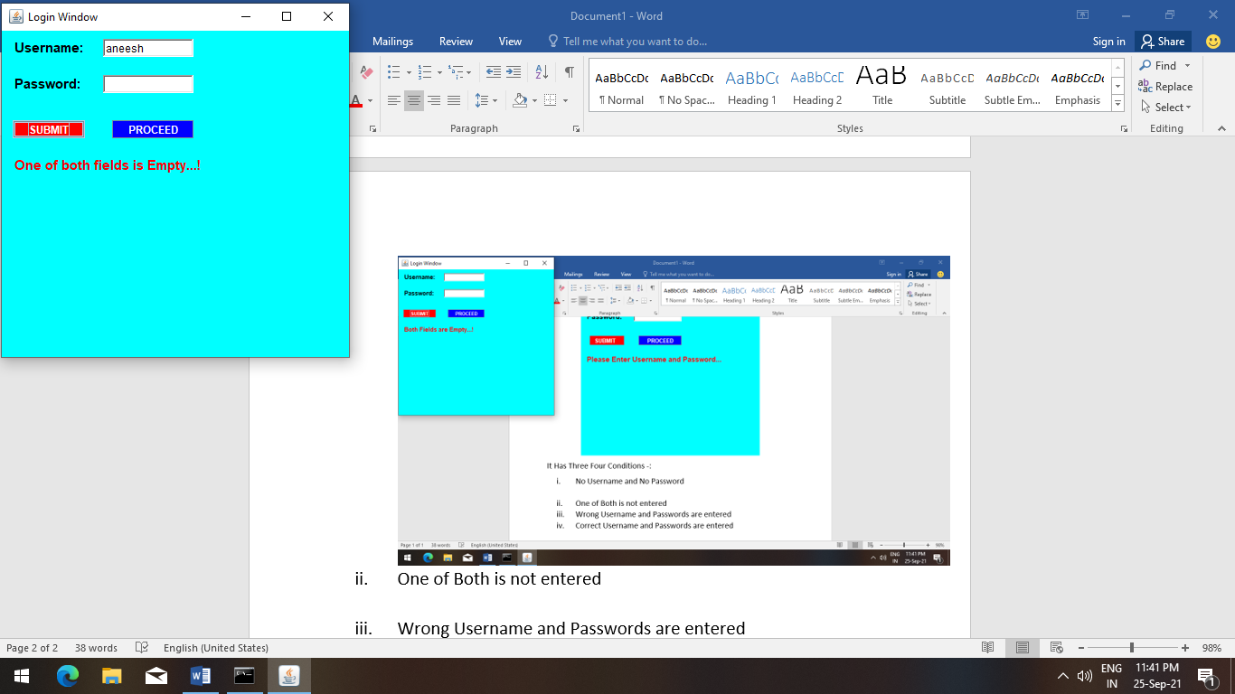

1. **Wrong Username and Passwords are entered**

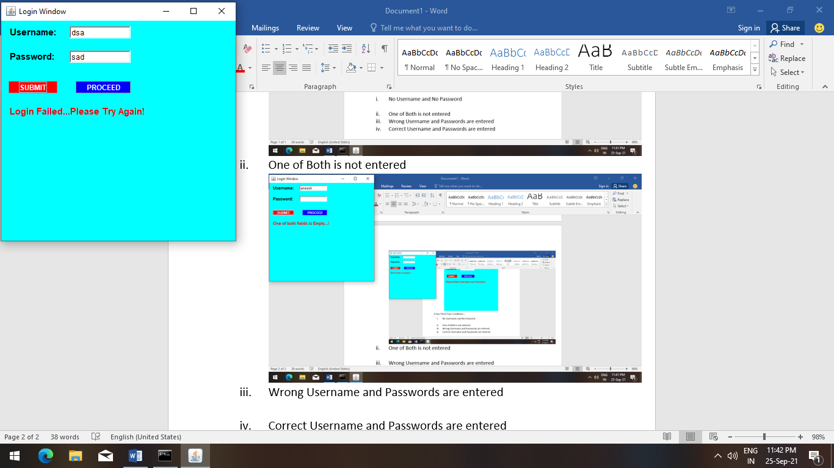

1. **Correct Username and Passwords are entered**

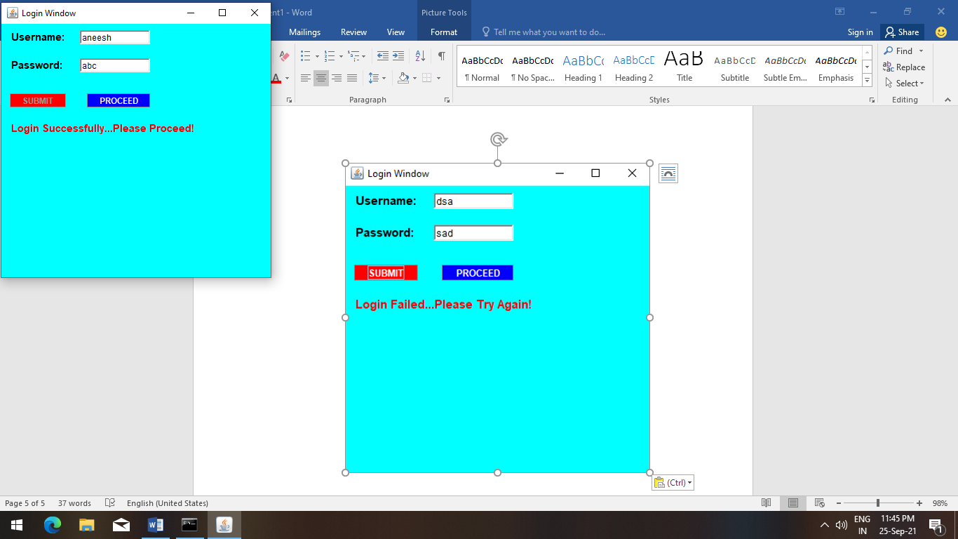

**Note -: *When You Entered Correct Username and Password, Submit Button is disabled***

**After Proceed -> *Proceed Button is also disabled!***

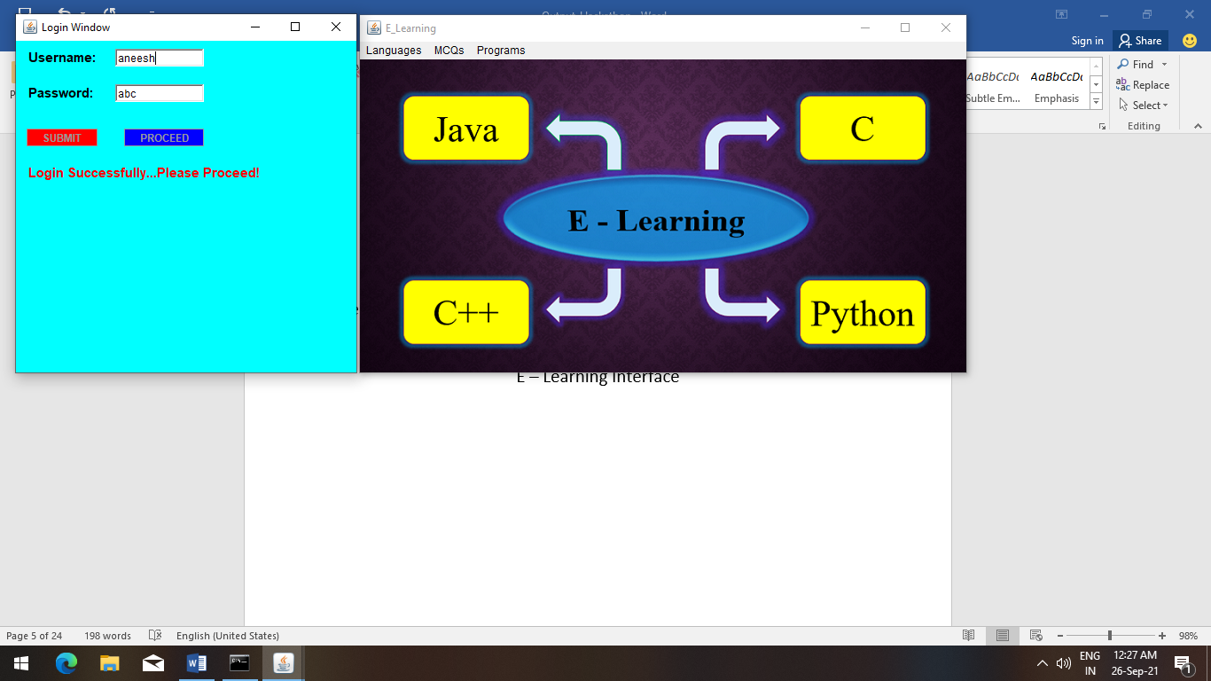

**E – Learning Interface**

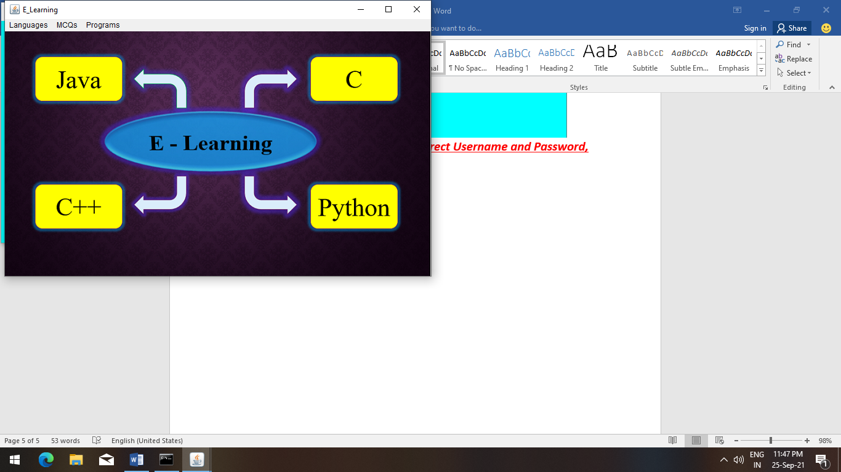

**There are Three Tabs -:**

1. **Languages -: It has One Menu -> Founders**

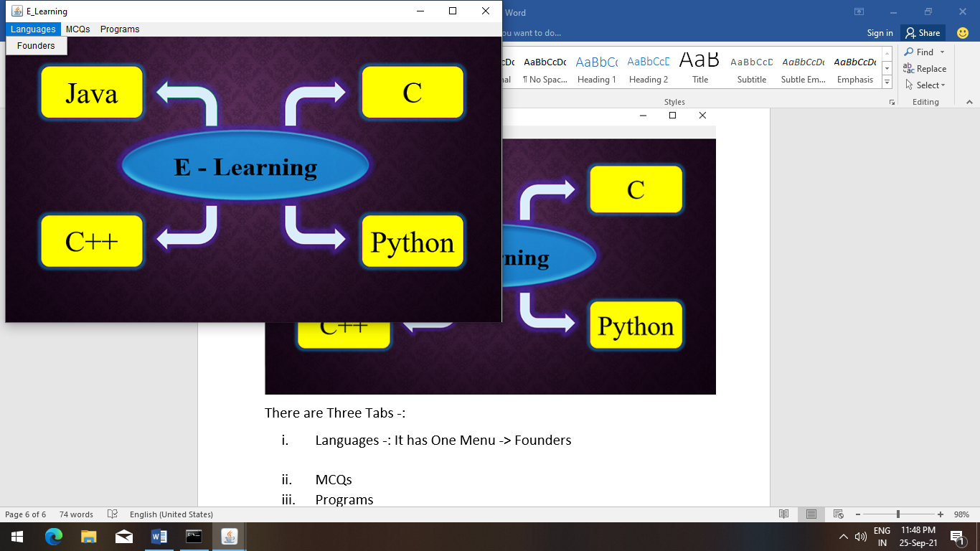

**Founders Menu -:**

**There are founders of 4 languages as you have seen at interface -:**

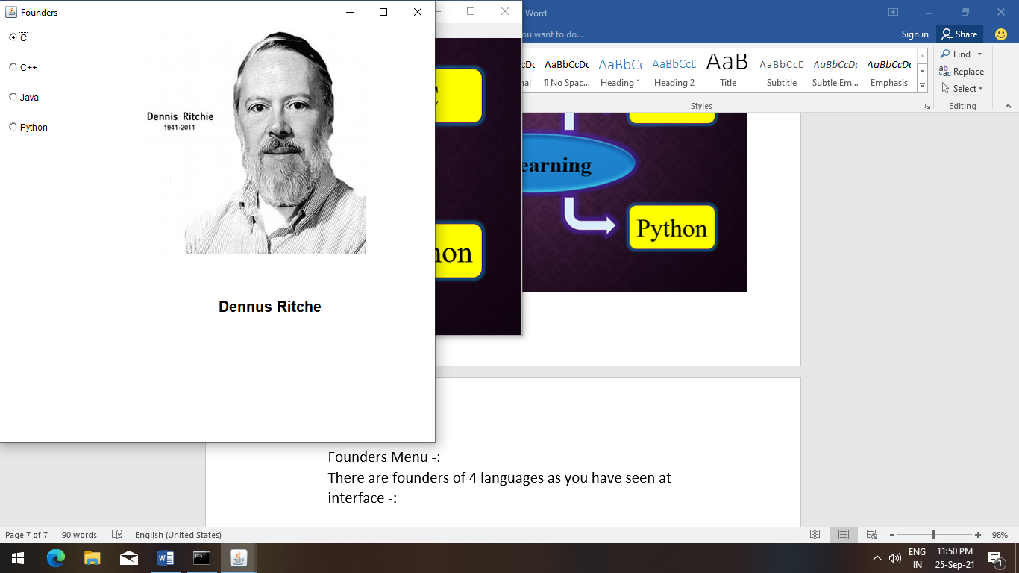

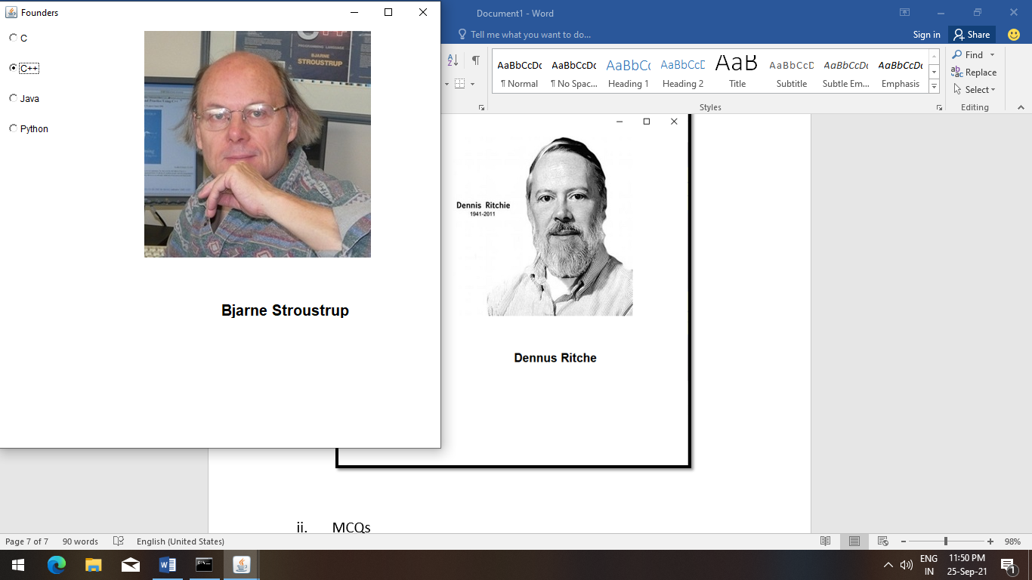

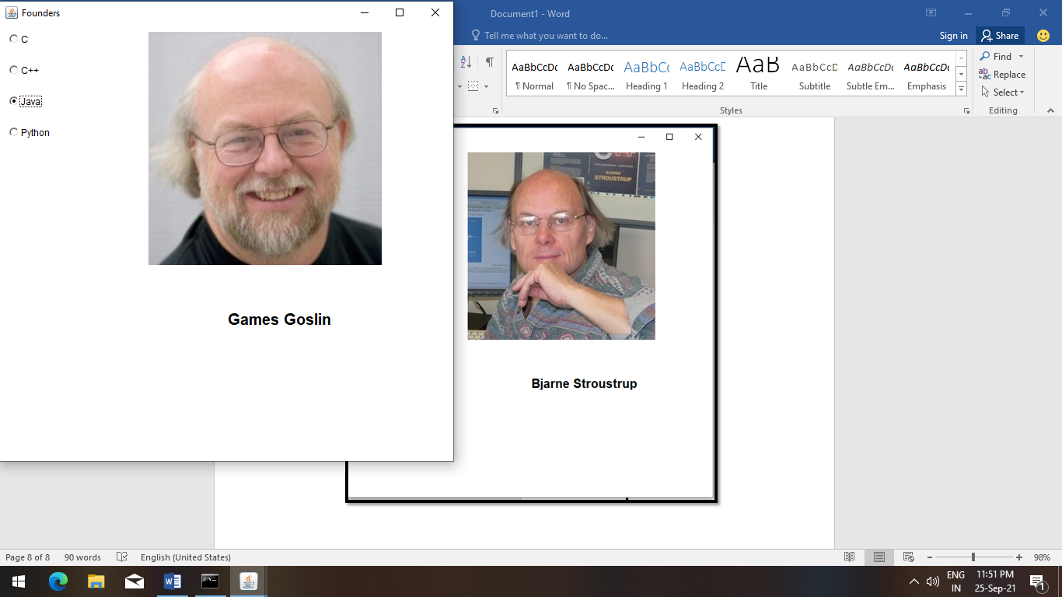

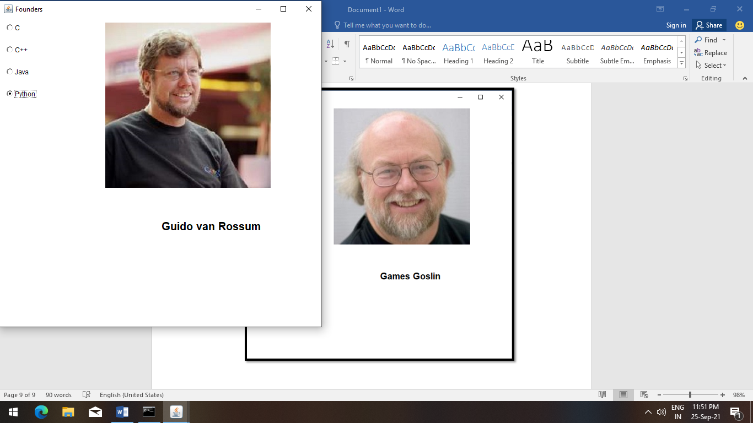

1. **MCQs -: In this Tab We provide Five options(Menus)**
2. **C MCQ**
3. **C++ MCQ**
4. **Java MCQ**
5. **Advanced Java MCQ**
6. **Python MCQ**

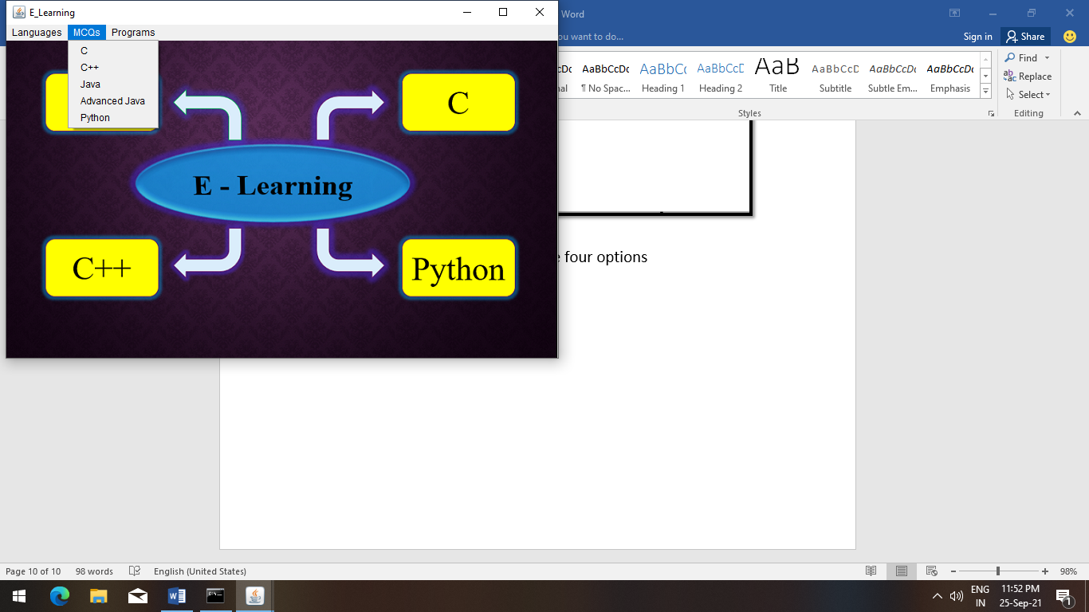

**Note -: When Any Menu opens, immediately it will disabled because no one should open multiple windows at a time**

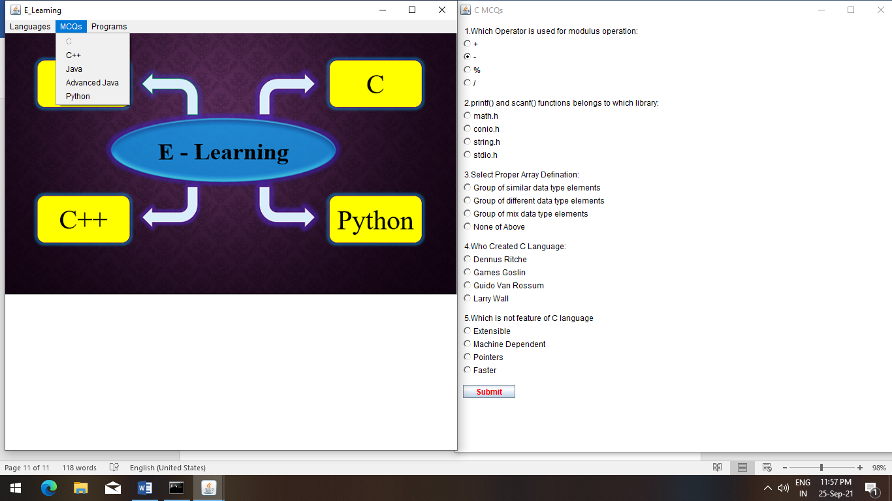

1. **C MCQs**

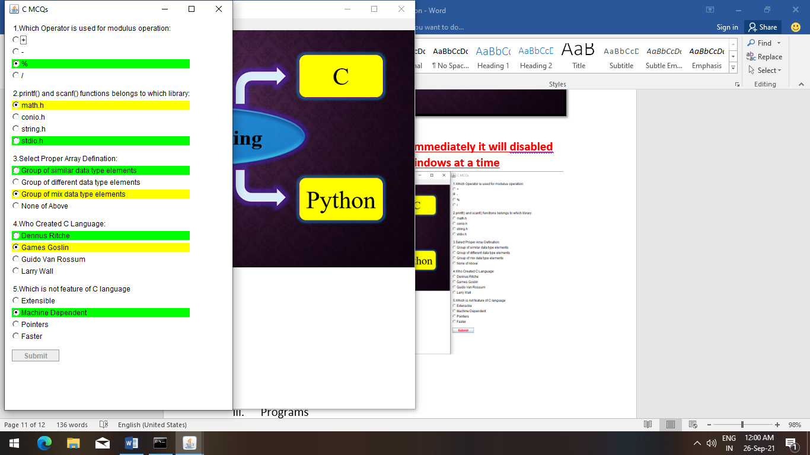

**Note -: Similarly, Submit Button is also disabled because no one use it at a time!**

1. **C++ MCQs**

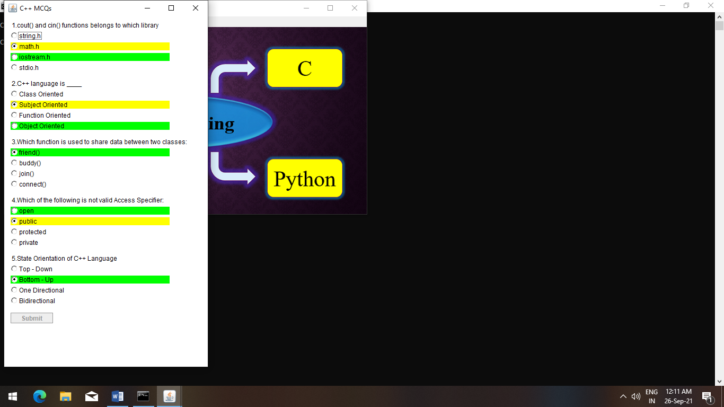

1. **Java MCQs**

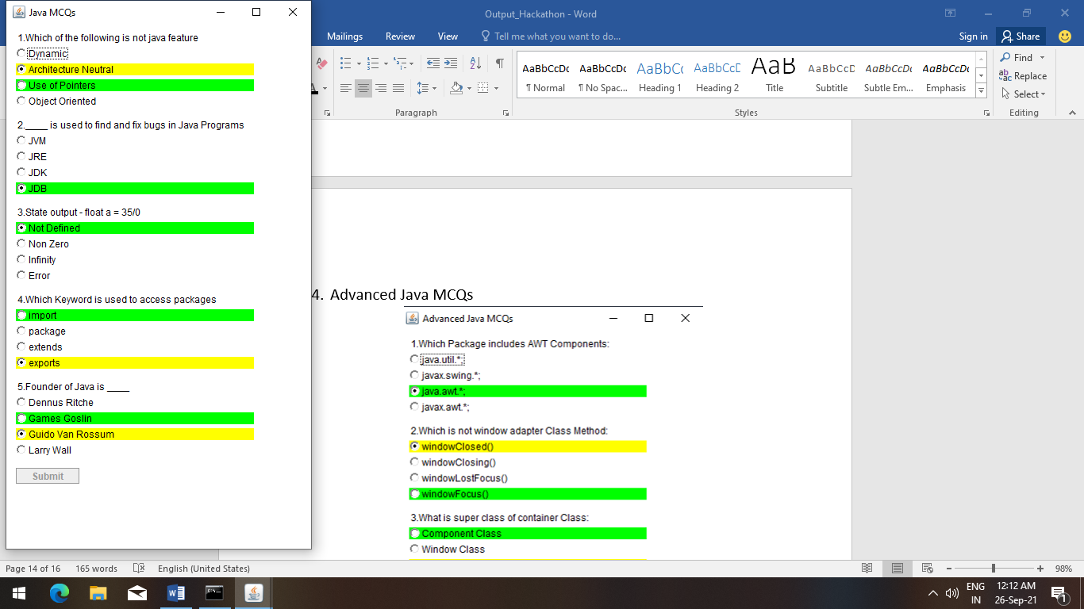

1. **Advanced Java MCQs**

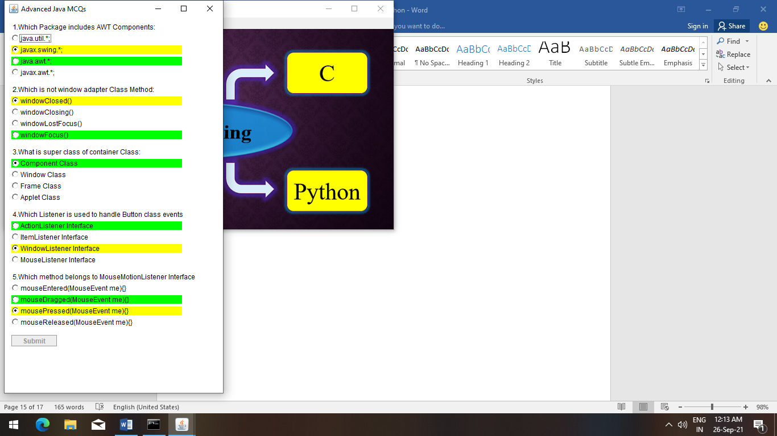

1. **Python MCQs**

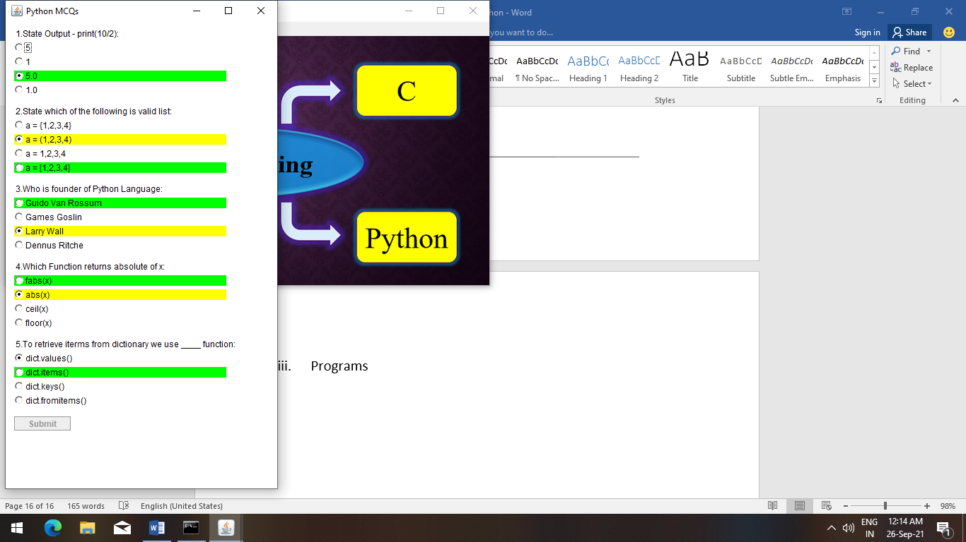

1. **Programs -:**

**We have Provide Programs in Two Languages -:**

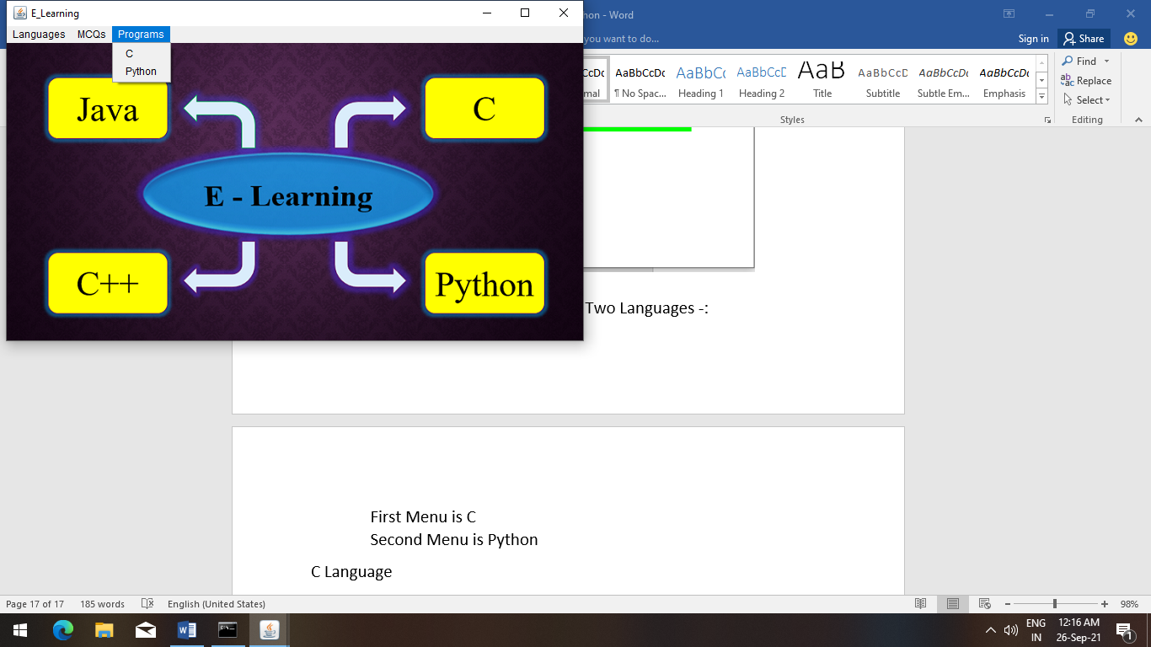

**First Menu is C**

**Second Menu is Python**

**C Language Programs -:**

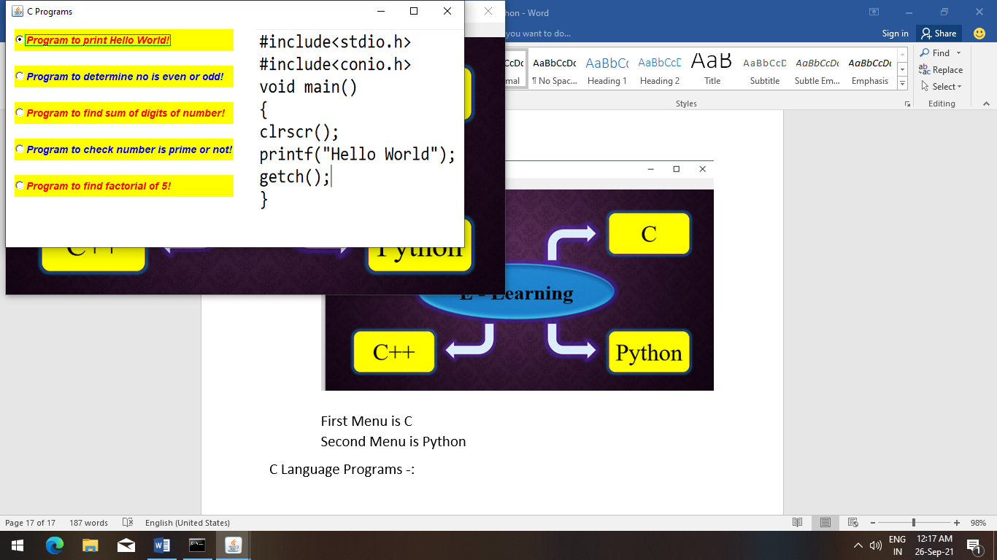

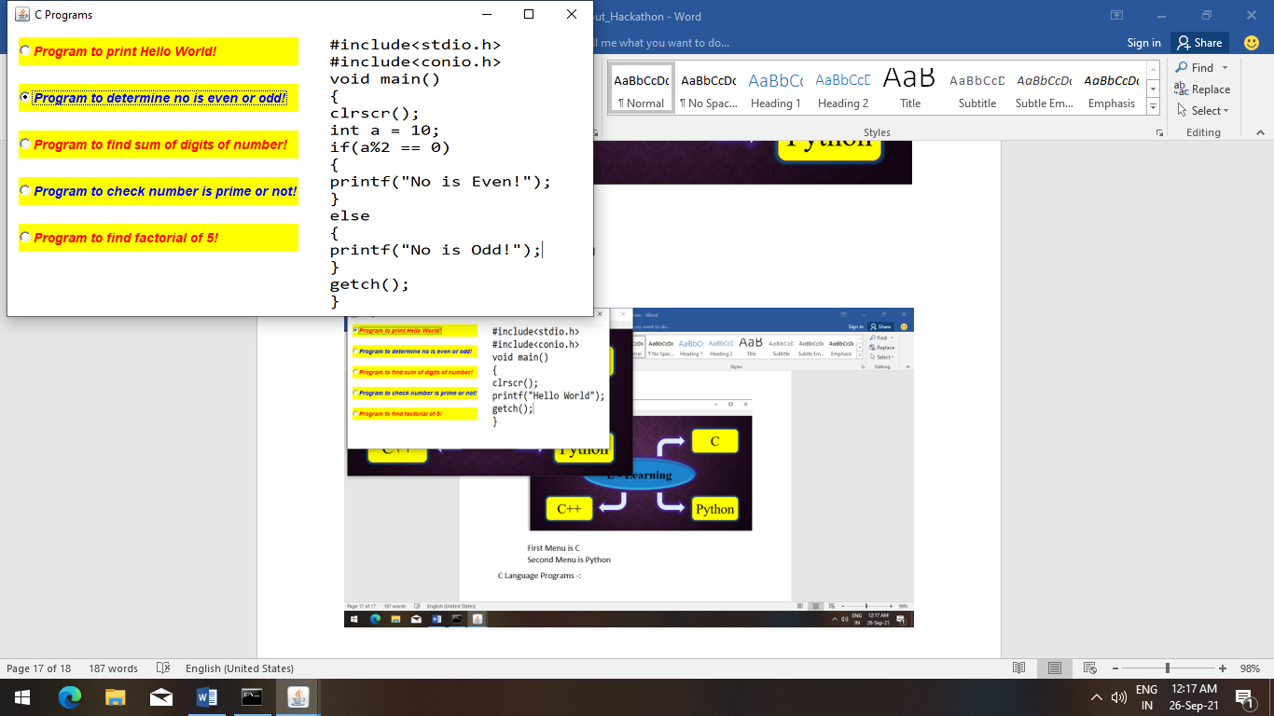

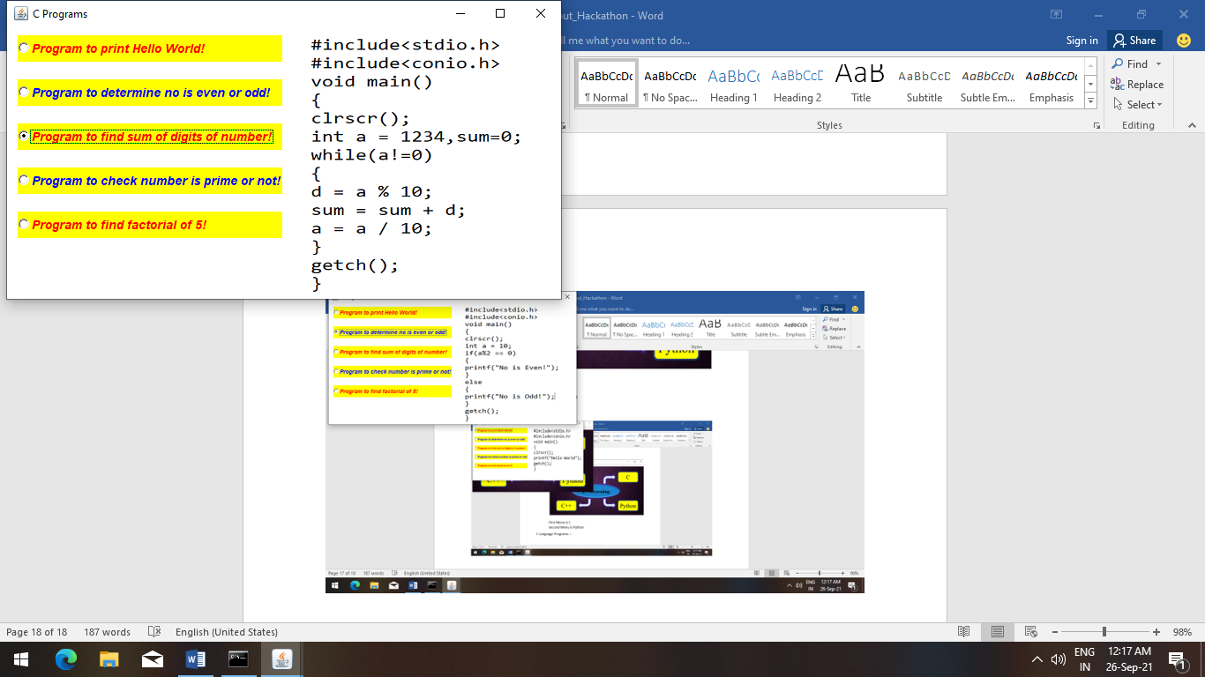

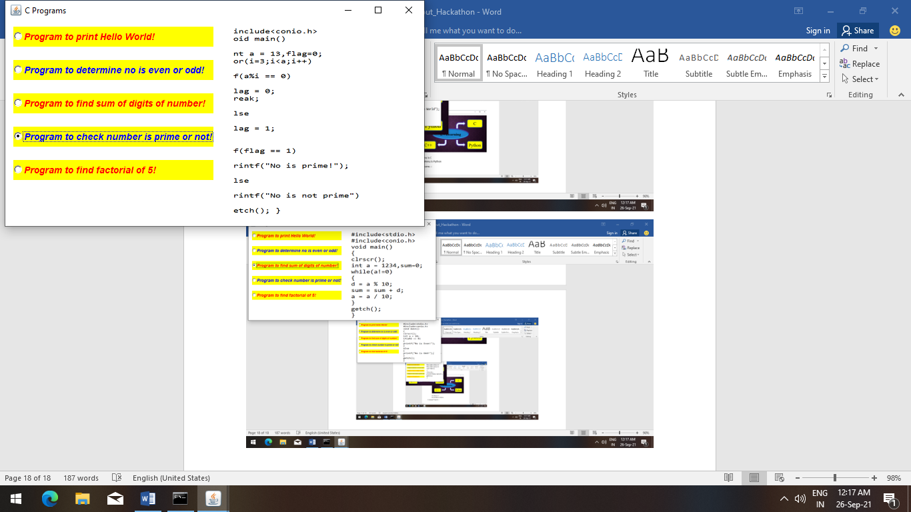

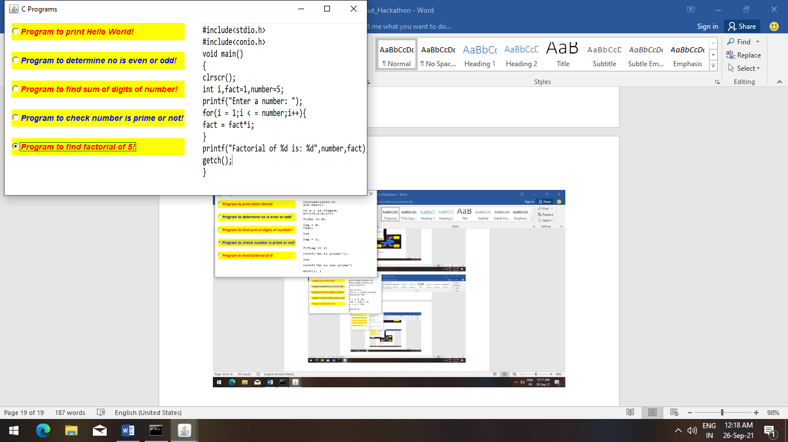

**Python Language Programs -:**

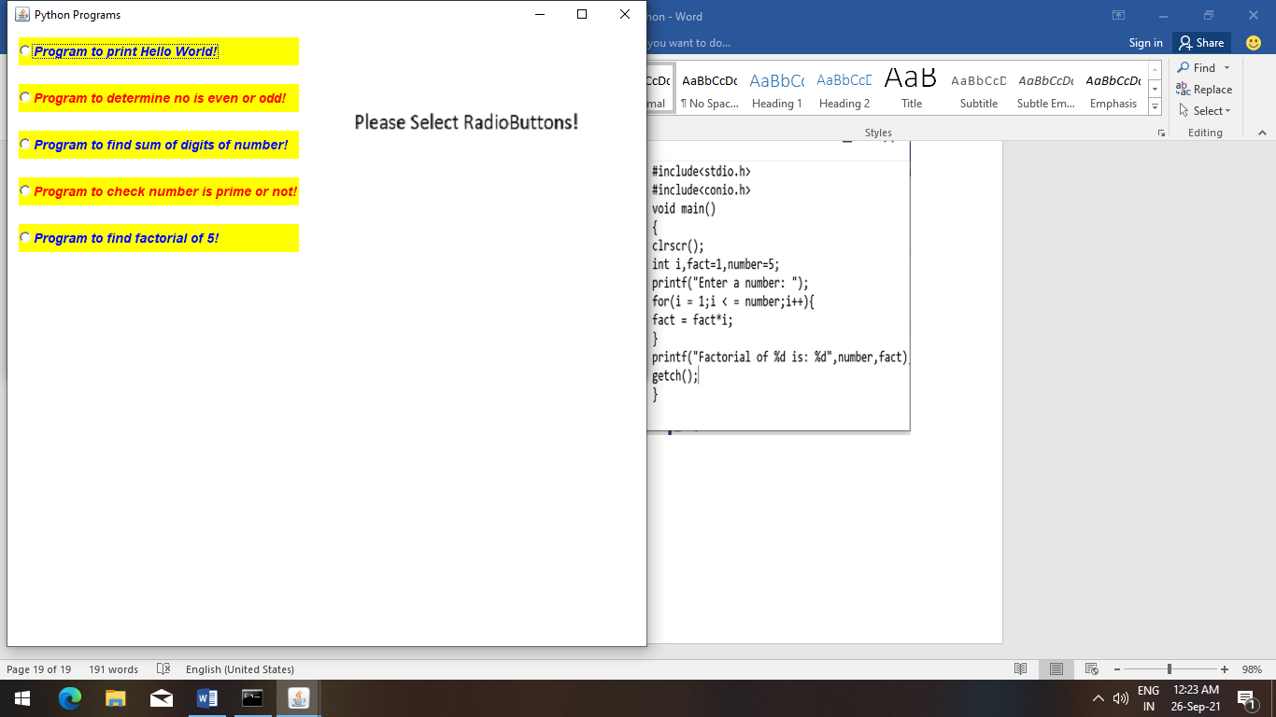

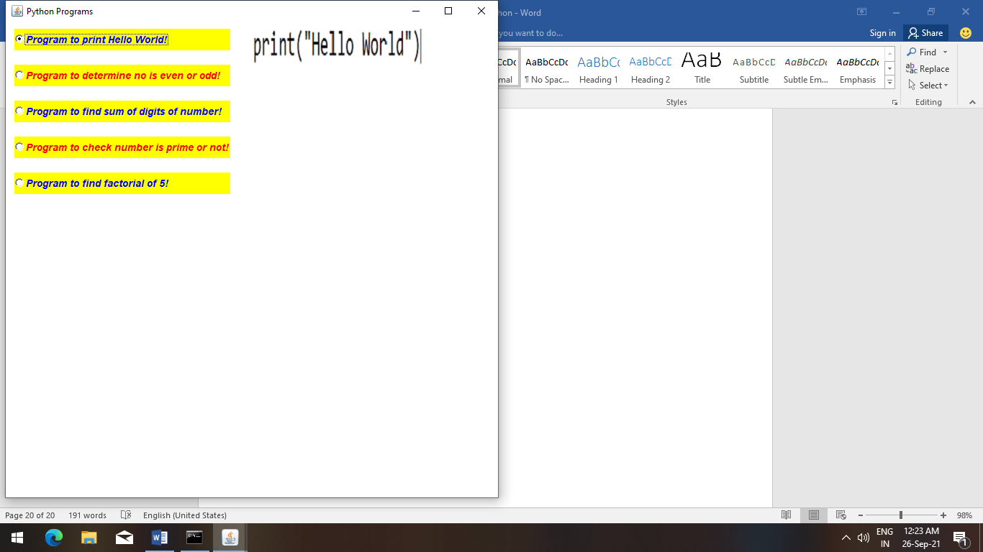

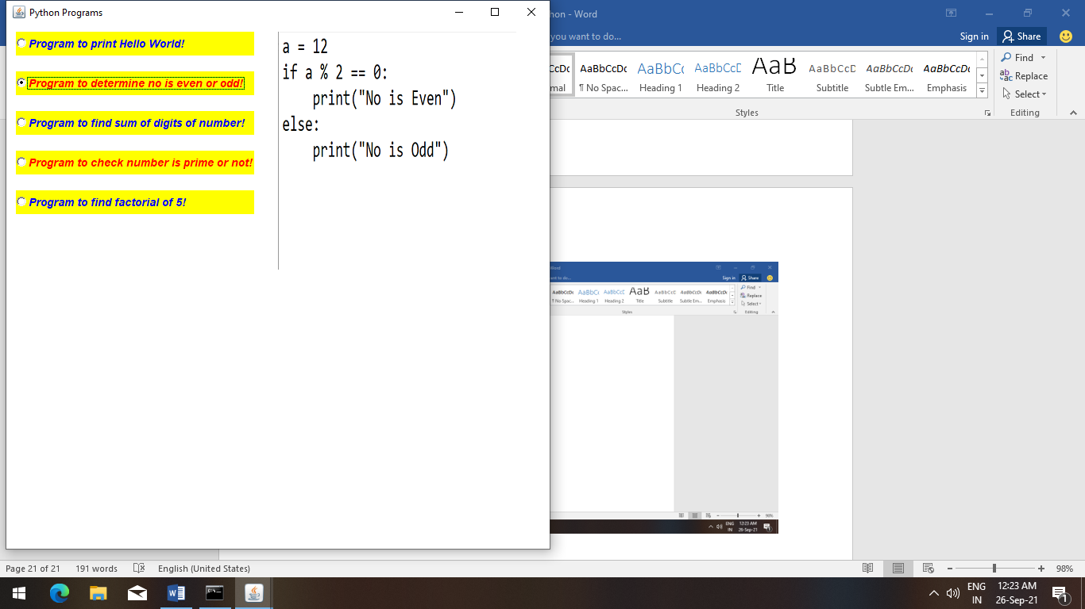

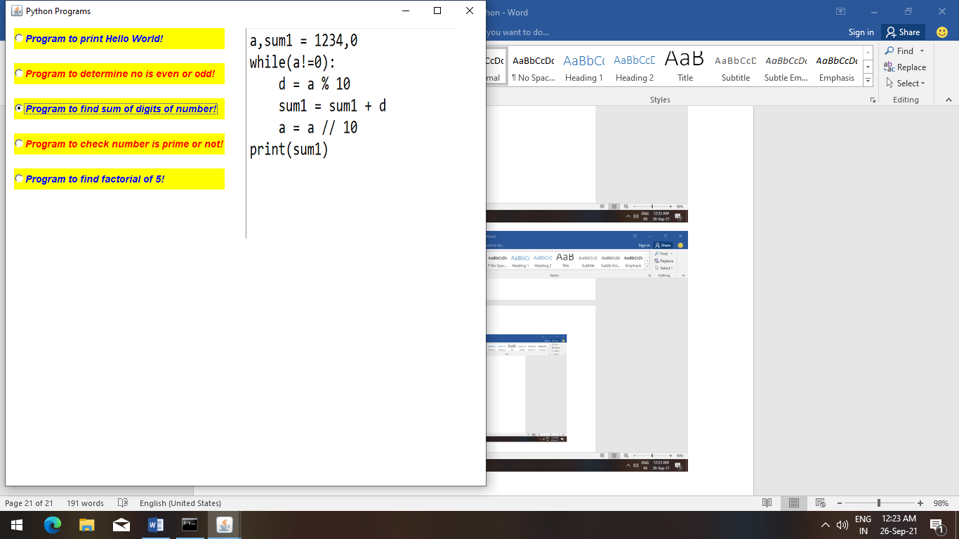

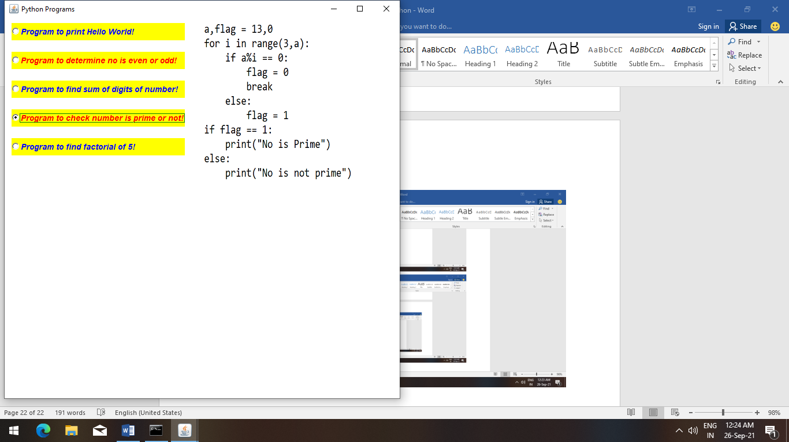

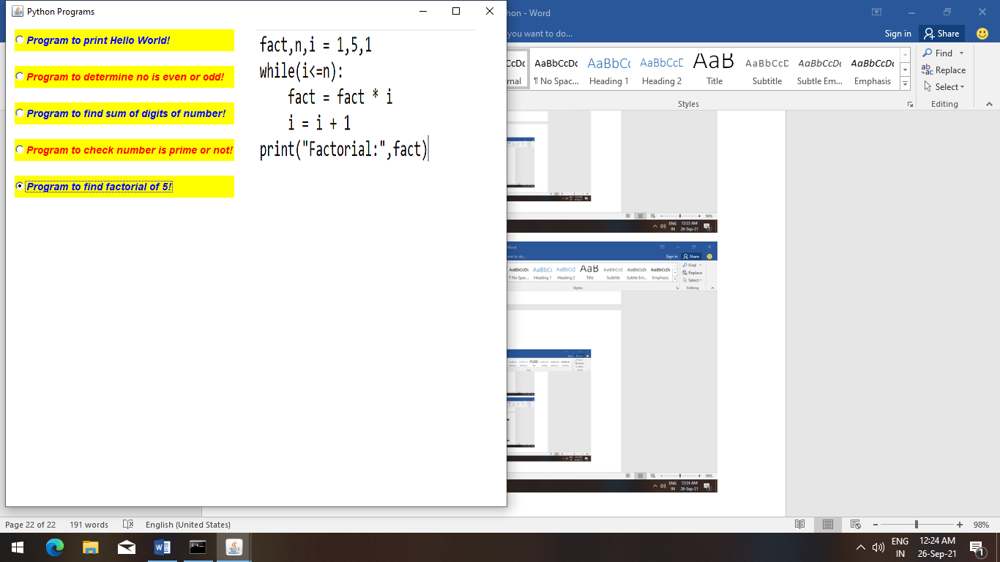

**Thank You!**